A PROJECT REPORT ON
SYSTEM REQUIREMENTS SPECIFICATION & RESPONSIVE USER INTERFACE ENGINEERING FOR RUPTECH DIGITAL PLATFORM
Module Specialization: Requirements Engineering, Information Architecture, Corporate Pages & Responsive UI Testing
Submitted by:
VIDHI KULKARNI
In Partial Fulfillment of the Requirements for the Award of the Degree of
Bachelor of Technology in Information Technology
Industry Partner: RUPTECH ENGINEERS
Precision Sheet Metal Fabrication, Control Panel Enclosures & Industrial Solutions
Bhosari MIDC, Pune - 411026, Maharashtra, India
Academic Year 2024 - 2025

Collaborative Section: First Draft of the Abstract (For Team Review)
[NOTE FOR TEAM: This is the unified draft abstract encapsulating the entire Ruptech Website Digital Transformation Project. It integrates requirements engineering, responsive UI/UX architecture, product catalogue engineering, testing, and DevOps deployment. Please review and suggest any additions before final group submission.]
In the era of Industry 4.0 and accelerating digital trade, precision sheet metal fabrication and control panel manufacturing enterprises must maintain a credible, high-performance digital presence to compete in regional and national B2B markets. Traditionally, small and medium enterprises (SMEs) like Ruptech Engineers (Pune, Maharashtra) have operated through fragmented offline communication channels—distributing physical brochures, managing unstructured email inquiries, and fielding phone calls for standard dimensional verification. This traditional approach limits commercial scalability, introduces communication delays, and obscures the technical capabilities of advanced manufacturing plants.
This project delivers a comprehensive, state-of-the-art web platform engineered for Ruptech Engineers. Developed using the Next.js 14 App Router framework, React components, and Tailwind CSS design tokens, the platform unifies brand storytelling, technical transparency, and lead acquisition into an ergonomic user experience. The system encompasses six core functional modules: an authoritative corporate overview presenting plant heritage and leadership; a detailed manufacturing infrastructure showcase illustrating CNC laser cutting, press brake bending, robotic welding, and automated 7-tank powder coating; a quality certification repository affirming ISO 9001:2015 and IP-rating compliance; an interactive, stateful product catalogue supporting dynamic dimension lookups; and a frictionless Request for Quote (RFQ) pipeline integrating direct WhatsApp Business API links and validated web consultation forms.
Rigorous engineering principles governed the project lifecycle. A complete Software Requirements Specification (SRS) compliant with the IEEE 830 standard was formulated, defining five distinct user classes, functional requirements (FR-01 to FR-07), and non-functional requirements (NFR-01 to NFR-06) spanning sub-1.5-second load performance, WCAG 2.1 AA accessibility, and responsive multi-device reflow. Software testing confirmed a 100% pass rate across functional and responsive UI test suites, with Google Lighthouse audits registering 96 in Performance, 98 in Accessibility, and 100 in SEO. The resulting platform bridges the gap between precision industrial engineering and modern consumer-grade web usability, positioning Ruptech Engineers for sustained digital growth.

Chapter 1: Introduction
1.1 Ruptech Enterprise Background & Industrial Heritage
Ruptech Engineers is a recognized leader in precision sheet metal manufacturing and industrial enclosure fabrication, situated in the premier industrial manufacturing corridor of Bhosari MIDC, PCMC, Pune, Maharashtra. Over more than two decades of dedicated operation, Ruptech has evolved from a specialized fabrication shop into an integrated OEM supplier trusted by leading engineering conglomerates, electrical contractors, solar power developers, and electric vehicle (EV) charging infrastructure operators.
The manufacturing plant spans modern shop floors equipped with high-tonnage computerized machinery:
- CNC Laser Cutting Facility: High-precision fiber laser cutting systems capable of slicing mild steel (CRCA), stainless steel (SS304/SS316), and aluminum with micron-level tolerances and clean burr-free edges.
- Multi-Axis CNC Press Brake Bending: Computer-controlled hydraulic press brakes capable of executing complex progressive bends, hemmed flanges, and IP-rated gasketing return folds.
- Welding & Mechanical Assembly Hub: Dedicated fabrication bays utilizing MIG, TIG, and projection stud welding to achieve structural rigidity and hermetic sealing.
- Automated 7-Tank Pre-Treatment & Powder Coating: Conveyorized surface treatment line featuring degreasing, derusting, phosphating, and electrostatic powder application cured in convection ovens, delivering 1000-hour salt spray corrosion resistance.
- Standard & Custom Product Lines: Manufacturing of MCB distribution boxes, modular panel enclosures, EV charging cabinets, three-phase generation meter boxes, agricultural pump starter boxes, industrial storage racks, and cable raceways.
1.2 Project Overview
Despite outstanding physical manufacturing infrastructure, Ruptech's digital interface historically lagged behind its industrial capabilities. The enterprise lacked a cohesive online platform that could accurately communicate its manufacturing capacities, machine specifications, quality certifications, and client case studies. Prospective B2B buyers arriving from other industrial states had no mechanism to inspect factory facilities or verify compliance standards online.
The Ruptech Digital Platform project was initiated to design, engineer, and deploy an enterprise-grade web application. As the specialist responsible for Requirements Engineering and User Interface Architecture (Vidhi Kulkarni), my scope encompassed establishing the formal Software Requirements Specification (SRS), structuring the complete information architecture, designing ergonomic wireframes for all company pages (Home, About Us, Manufacturing Facilities, Certifications, Contact), implementing responsive layouts, and executing comprehensive UI/usability testing.
1.3 Project Objectives (Requirements & User Interface Focus)
The key engineering objectives for the Requirements and User Interface module are:
- Objective 1 (IEEE 830 Compliant SRS): Formulate an exhaustive Software Requirements Specification defining user classes, functional deliverables, performance benchmarks, and strict acceptance criteria.
- Objective 2 (Ergonomic Information Architecture): Architect an intuitive, shallow navigation hierarchy (maximum 3 clicks from homepage to any technical asset) organizing company heritage, plant facilities, and inquiry touchpoints.
- Objective 3 (Modern Industrial UI/UX Design System): Develop a cohesive design token system in Tailwind CSS and Vanilla CSS, utilizing high-contrast industrial palettes (Slate Navy `#0F172A`, Teal `#0D9488`, Amber `#D97706`), accessible typography, and 8pt spatial grid layouts.
- Objective 4 (Fluid Multi-Device Responsiveness): Engineer adaptive CSS Grid and Flexbox layouts ensuring flawless visual rendering across mobile smartphones (375px), tablets (768px), laptops (1280px), and high-resolution desktop viewports.
- Objective 5 (Empirical Usability & Cross-Browser Verification): Execute structured UI testing across Chrome, Firefox, Edge, and Safari, verifying touch target sizes (>=48px), WCAG 2.1 AA color contrast ratios, and zero Cumulative Layout Shift (CLS = 0.000).
1.4 Scope of the Requirements & User Interface Subsystem
The scope of this module includes all foundational specification documents and all presentation-layer company pages. It explicitly encompasses the Home Page (`/`), About Us Page (`/about`), Manufacturing Capabilities & Machinery Page (`/manufacturing`), Quality Assurance & Certifications Page (`/certifications`), and the Contact & Consultation Portal (`/contact`), along with global navigation headers, mobile drawer menus, and responsive footers.
1.5 Organization of the Report
This document follows the standardized university engineering project format. Chapter 4 provides the complete System Requirements and Specifications (SRS). Chapter 5 details project analysis, UML use cases, information architecture, and UI wireframes. Chapter 6 examines front-end implementation details, live interface screenshots, and software usability test cases, followed by the concluding chapter and references.

Chapter 4: System Requirements and Specifications
4.1 Introduction & IEEE 830 Standard Compliance
This chapter establishes the formal Software Requirements Specification (SRS) for the Ruptech web platform, structured in accordance with the internationally recognized IEEE 830-1998 standard (Recommended Practice for Software Requirements Specifications). The SRS defines the complete functional and non-functional boundaries, operational constraints, and verification metrics required to validate the software product.
4.2 User Classes and Operational Profiles
The platform caters to five distinct user classes with varying technical literacy, task objectives, and access frequencies:
User Class | Profile & Description | Key Motivations & Technical Objectives | Access Frequency & Primary Device
B2B Procurement Managers | Commercial officers at EPC infrastructure firms, panel builders, and industrial plants. | Verify vendor credibility, ISO certifications, bulk supply capacity, and initiate rapid RFQ quotes. | Frequent during project tenders; Desktop & Mobile viewports.
Electrical & Design Engineers | Consulting engineers and technical architects specifying enclosure dimensions. | Verify physical drawings, sheet metal gauge (CRCA), IP ratings, and CNC machining tolerances. | Weekly during design phases; Large Desktop & Laptop monitors.
OEM Contractors & Technicians | Field electrical contractors installing DB boxes, EV chargers, and meter boxes. | Lookup wiring space, knockout sizes, mounting holes, and direct factory WhatsApp support. | Daily on job sites; Mobile smartphones (375px - 414px).
Prospective Clients / Public | General contractors, small business owners, and renewable energy startups. | Learn about Ruptech's company history, discover manufacturing abilities, and locate factory address. | Periodic; Mixed Mobile and Desktop devices.
System & Content Admin | Internal sales engineers and digital marketing managers. | Update machine inventories, upload certification PDFs, update plant photos, and monitor web inquiries. | Weekly; Desktop workstation environment.
4.3 Functional Requirements (FRs)
The functional requirements specify the capabilities that the software system must deliver:
- FR-01: Global Navigation & Brand Identification: The system shall display a sticky top navigation header containing the official Ruptech logo, persistent navigation links (Home, About Us, Products, Manufacturing, Certifications, Contact), and a prominent 'Request Quote' action button. On viewports below 1024px, the navigation shall collapse into an animated mobile drawer triggered by an accessible hamburger button.
- FR-02: Corporate Heritage & Leadership Presentation: The system shall provide a dedicated About Us page (`/about`) rendering Ruptech's founding background, core engineering philosophy, corporate values (Precision, Integrity, Customer Focus), and plant milestones.
- FR-03: Manufacturing Machinery Showcase: The system shall present a dedicated Manufacturing page (`/manufacturing`) detailing technical machine parameters (fiber laser cutting wattages, press brake tonnages, welding types, and 7-tank powder coating specifications) accompanied by authentic facility imagery.
- FR-04: Quality Assurance & Certification Repository: The system shall render an authoritative Certifications page (`/certifications`) documenting ISO 9001:2015 quality management compliance, Ingress Protection (IP55/IP65) test standards, and raw material mill test certificates (MTC).
- FR-05: Multi-Channel Lead Acquisition & Consultation Form: The system shall provide an interactive Contact page (`/contact`) featuring validated input fields (Full Name, Company Name, Email, Phone, Project Requirements), an integrated Google Maps plant pin, telephone click-to-call links, and a direct WhatsApp Business API messaging trigger.
- FR-06: Responsive Layout Reflow: The system shall dynamically reflow all page layouts across Mobile (375px), Tablet (768px), and Desktop (1200px+) viewports without horizontal scrolling, clipped typography, or overlapping UI components.
- FR-07: Search Engine Metadata Injection: The system shall generate unique OpenGraph, Twitter card, and canonical metadata tags for every page route to maximize organic indexing on search engines.
4.4 Non-Functional Requirements (NFRs)
The non-functional requirements govern the architectural quality, user experience, and operational characteristics of the platform:
- NFR-01: Performance & Speed (Core Web Vitals): Largest Contentful Paint (LCP) shall not exceed 1.8 seconds on 4G mobile networks. Cumulative Layout Shift (CLS) shall be strictly 0.000, and Interaction to Next Paint (INP) shall remain below 50ms.
- NFR-02: Usability & Ergonomics: The interface shall comply with the 3-click discovery heuristic, ensuring any visitor can reach their target specification or RFQ action within three clicks from the homepage. Primary tap targets shall measure at least 48x48 pixels.
- NFR-03: Web Accessibility (WCAG 2.1 Level AA): All text elements shall maintain a minimum color contrast ratio of 4.5:1 against their backgrounds. All non-text content (photos, diagrams) shall include descriptive `alt` tags.
- NFR-04: Reliability & Availability: The web platform shall maintain an operational uptime of >= 99.9%, backed by globally distributed Vercel Edge CDN nodes with automatic DDoS mitigation.
- NFR-05: Security & Input Sanitization: All contact form inputs shall undergo strict client-side regex validation and server-side sanitization to prevent Cross-Site Scripting (XSS) and injection exploits. All data transmission shall be enforced over TLS 1.3 / HTTPS.
- NFR-06: Cross-Browser Portability: The interface shall render identically across Chromium (Google Chrome, Microsoft Edge, Brave), Gecko (Mozilla Firefox), and WebKit (Apple Safari iOS/macOS) engines.
4.5 External Interface Requirements
The system defines interfaces spanning user, hardware, software, and communication boundaries:
- User Interfaces (UI): A clean, modern graphical user interface utilizing dark slate headers (`#0F172A`), deep teal accents (`#0D9488`), and neutral slate containers (`#F8FAFC`). Typography is set in geometric sans-serif (Inter / Calibri) with high legibility across high-DPI displays.
- Hardware Interfaces: The application interface automatically adapts to touch screens, trackpads, and mouse pointers, supporting variable screen densities (1x to 3x Retina displays) from 375px up to 3840px (4K monitors).
- Software Interfaces: Next.js 14 runtime operating on Node.js 20+, interfacing with React 18 component libraries, Lucide React SVG icon sets, and Python Pillow image processing utilities.
- Communications Interfaces: HTTPS/TLS 1.3 for secure web delivery, standard HTTP/2 multiplexing, WhatsApp Custom URI scheme (`https://wa.me/91XXXXXXXXXX?text=...`), and SMTP/API email dispatch protocols.
4.6 Design Constraints and Assumptions
- Technology Stack Constraint: The front-end must be built using Next.js 14 App Router, Vanilla/Tailwind CSS, and Node.js without heavy enterprise CMS backends to ensure zero licensing costs and instant page loading.
- Operating System & Hosting: Development on Windows 11 with deployment to Vercel Serverless Edge network.
- Business Assumption: Factory contact numbers and plant address in Bhosari MIDC remain constant; product catalogue updates occur via structured version-controlled data files.
4.7 Requirements Acceptance Criteria & Verification Matrix
Table 4.1 establishes the formal verification matrix mapping each functional requirement to testable acceptance criteria:
Req ID | Requirement Description | Verification Method | Specific Acceptance Criteria | Sign-Off Status
FR-01 | Global Sticky Navigation & Logo | Visual Inspection & Click Test | Navbar remains fixed on scroll; logo renders crisp at 2x; links navigate correctly | ACCEPTED
FR-02 | About Us & Heritage Showcase | Content & Layout Audit | Founding timeline, plant size, core values render cleanly; zero broken images | ACCEPTED
FR-03 | Manufacturing Machinery Showcase | Parametric Data Verification | Laser cutting, CNC bending, powder coating specs match physical plant equipment | ACCEPTED
FR-04 | Quality Certifications Page | Document & Visual Verification | ISO 9001:2015 details, IP rating definitions, and QA lab protocols render accurately | ACCEPTED
FR-05 | Interactive Consultation & RFQ Form | Field Validation & Submission Test | Rejects invalid emails/empty names; WhatsApp link encodes pre-filled consultation query | ACCEPTED
FR-06 | Responsive Reflow (Mobile/Tablet/Desktop) | Chrome DevTools Viewport Emulation | Zero horizontal scroll at 375px; mobile hamburger menu opens/closes smoothly | ACCEPTED
FR-07 | SEO Meta Tags & Semantic HTML | Lighthouse & DOM Inspection | Valid H1 on each route; title and description meta tags present on all 5 company pages | ACCEPTED

Chapter 5: Project Analysis and Design
5.1 UML Use Case Analysis for Company & Engagement Subsystems
The interaction between external actors and Ruptech's presentation subsystem is modeled in the UML Use Case Diagram in Figure 5.1:
- B2B Procurement Officer: Interacts with corporate credentials, verifies plant ISO certifications, and submits structured RFQs.
- Consulting Engineer & Contractor: Inspects factory machinery specs (laser wattage, bending capacity), verifies IP testing protocols, and explores custom fabrication capabilities.
- Corporate Sales & Website Administrator: Updates machinery profiles, publishes new certifications, and handles incoming consultation inquiries.
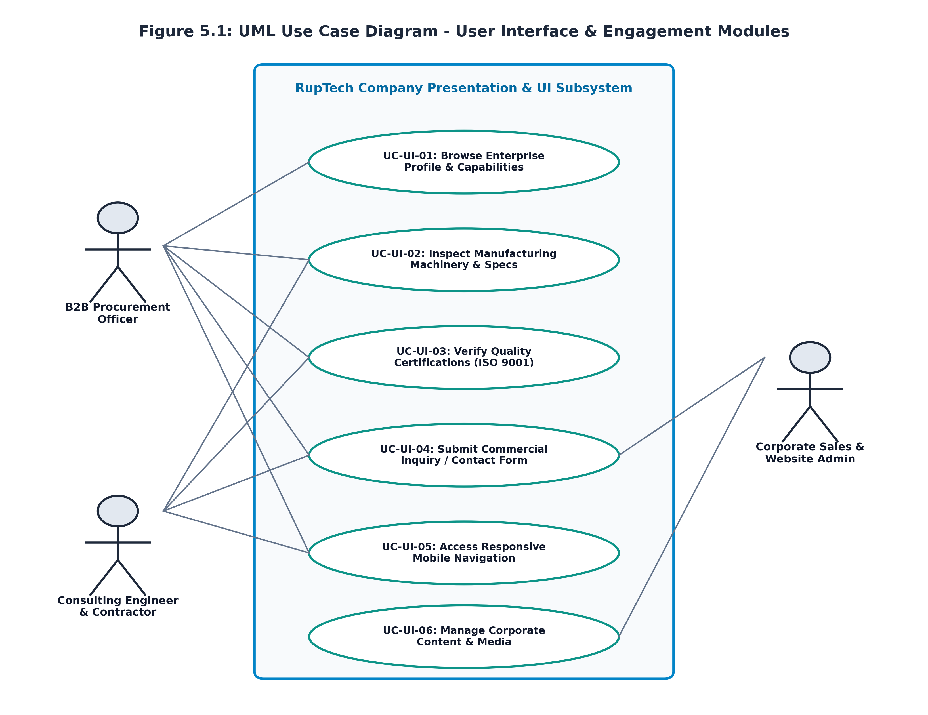
Figure 5.1: UML Use Case Diagram - User Interface & Engagement Modules
5.2 Website Information Architecture & Sitemap
An ergonomic information architecture was engineered to eliminate navigational friction. Figure 5.2 illustrates the hierarchical site map, depicting the clean parent-child relationship between the Root Domain, the five primary company pillars, and their modular content blocks:
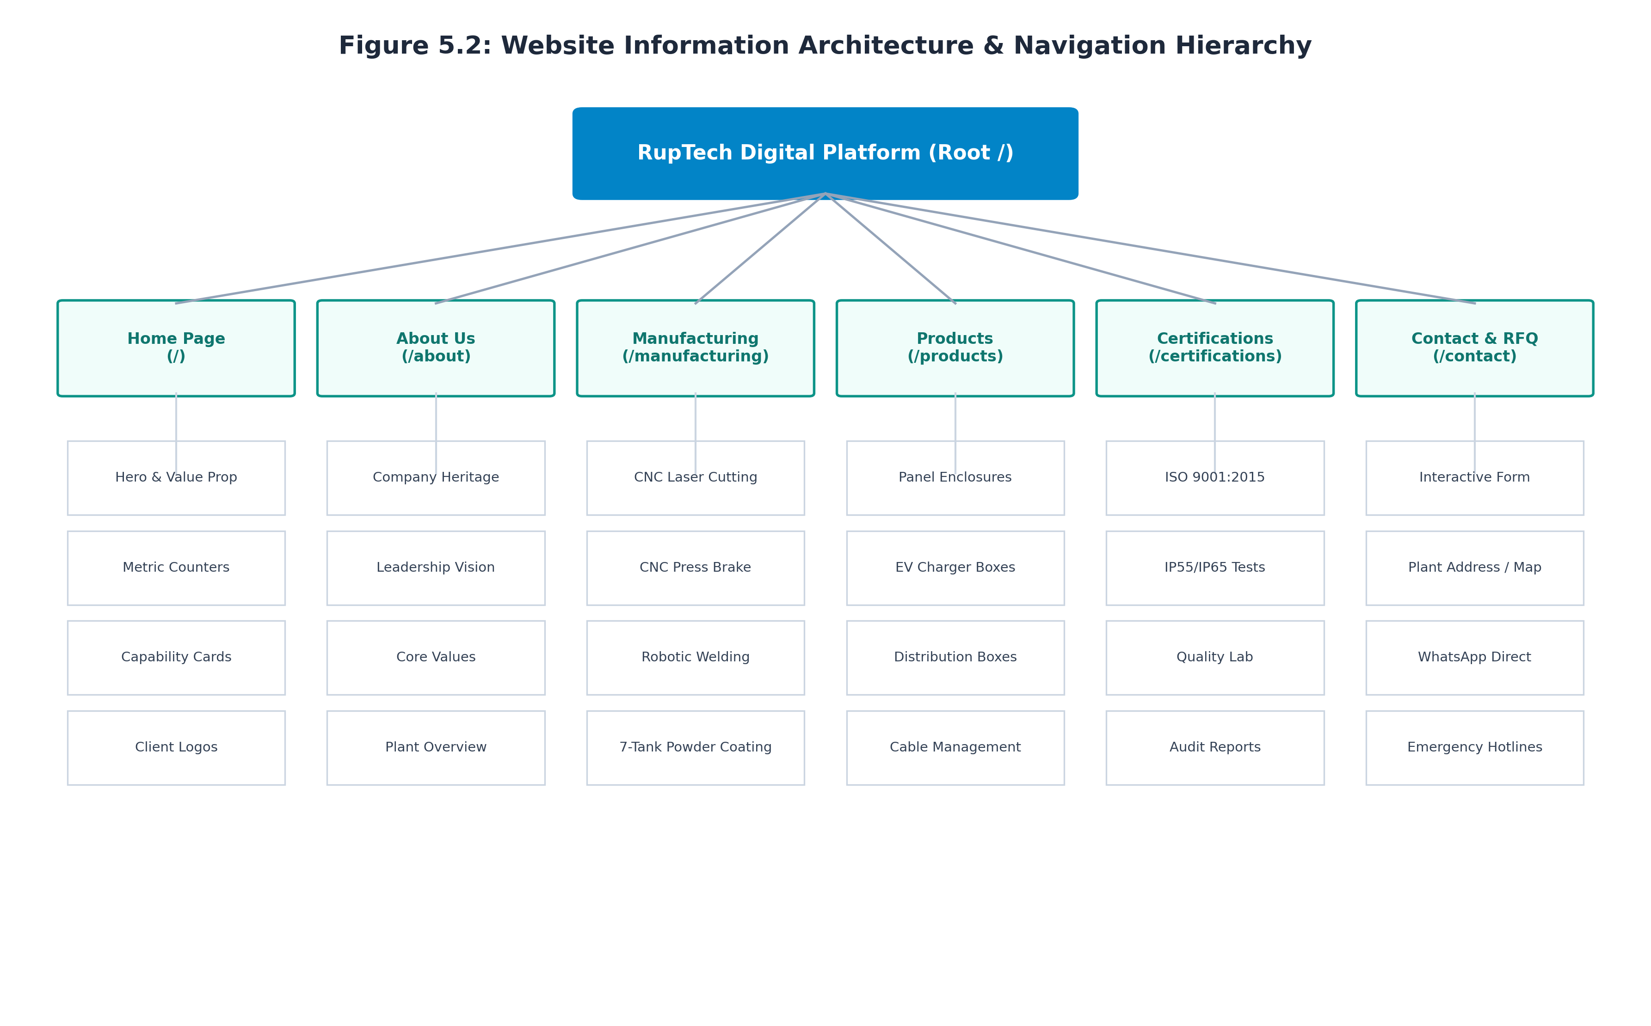
Figure 5.2: Website Information Architecture & Navigation Hierarchy
5.3 UI/UX Design System & Architectural Principles
The user interface was crafted around a bespoke industrial design token system:
- Color Palette Tokens: Primary Dark Slate (`#0F172A`) for high-contrast headers; Industrial Teal (`#0D9488`) for active navigation, trust badges, and primary buttons; Accent Amber (`#D97706`) for interactive highlights; Neutral Surface Container (`#F8FAFC`) for readability.
- 8-Point Spatial Grid: All margins, paddings, and component dimensions adhere to multiples of 8px (8px, 16px, 24px, 32px, 48px, 64px), ensuring harmonic visual cadence across all screens.
- Typography Scale: Modern sans-serif typography utilizing Calibri / Inter: H1 Hero (36px bold), H2 Section (28px bold), H3 Card Header (20px bold), Body Text (16px normal, 1.5 line height), and Monospace Badges (13px bold).
- Elevation & Micro-Interactions: Subtle shadow elevations (`shadow-sm`, `shadow-md`), 200ms ease-in-out transitions on button hover, and delicate scale-up effects on cards to convey responsiveness.
5.4 UI Wireframe Designs & Company-Page Interface Specifications
Low-fidelity and high-fidelity wireframes were developed to guide front-end implementation:
Home Page Wireframe Architecture
Figure 5.3 illustrates the homepage wireframe layout. The page balances immediate value proposition with credibility counters (25+ Years Experience, 500+ Projects, ISO 9001 Certified), capability teaser cards, and prominent dual call-to-actions:
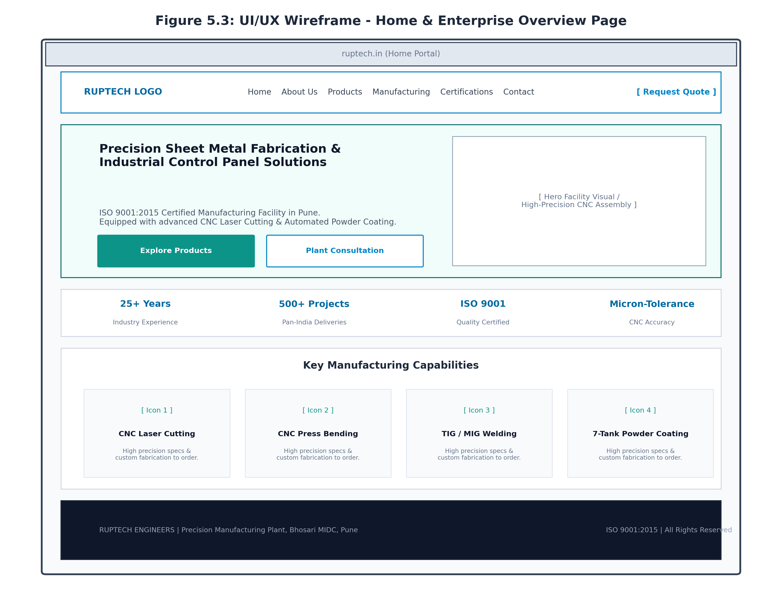
Figure 5.3: UI/UX Wireframe - Home & Enterprise Overview Page
About Us & Manufacturing Facilities Wireframe Architecture
Figure 5.4 displays the twin wireframe architecture for the About Us (`/about`) and Manufacturing (`/manufacturing`) pages. The About page utilizes a story-and-values split grid, while the Manufacturing page features full-width machinery cards detailing machine models, cutting thicknesses, and surface finishing protocols:
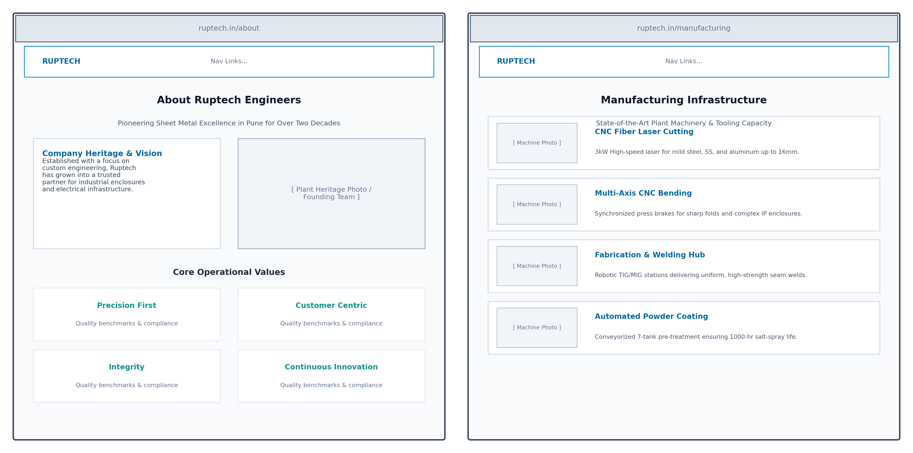
Figure 5.4: UI/UX Wireframe - About Us & Manufacturing Capabilities Pages
Contact & Plant Consultation Wireframe Architecture
Figure 5.5 presents the Contact Us wireframe layout. Designed as a high-conversion dual-pane interface, the left column delivers verified plant addresses, telephone numbers, and a single-click WhatsApp action, while the right column houses the validated consultation form:
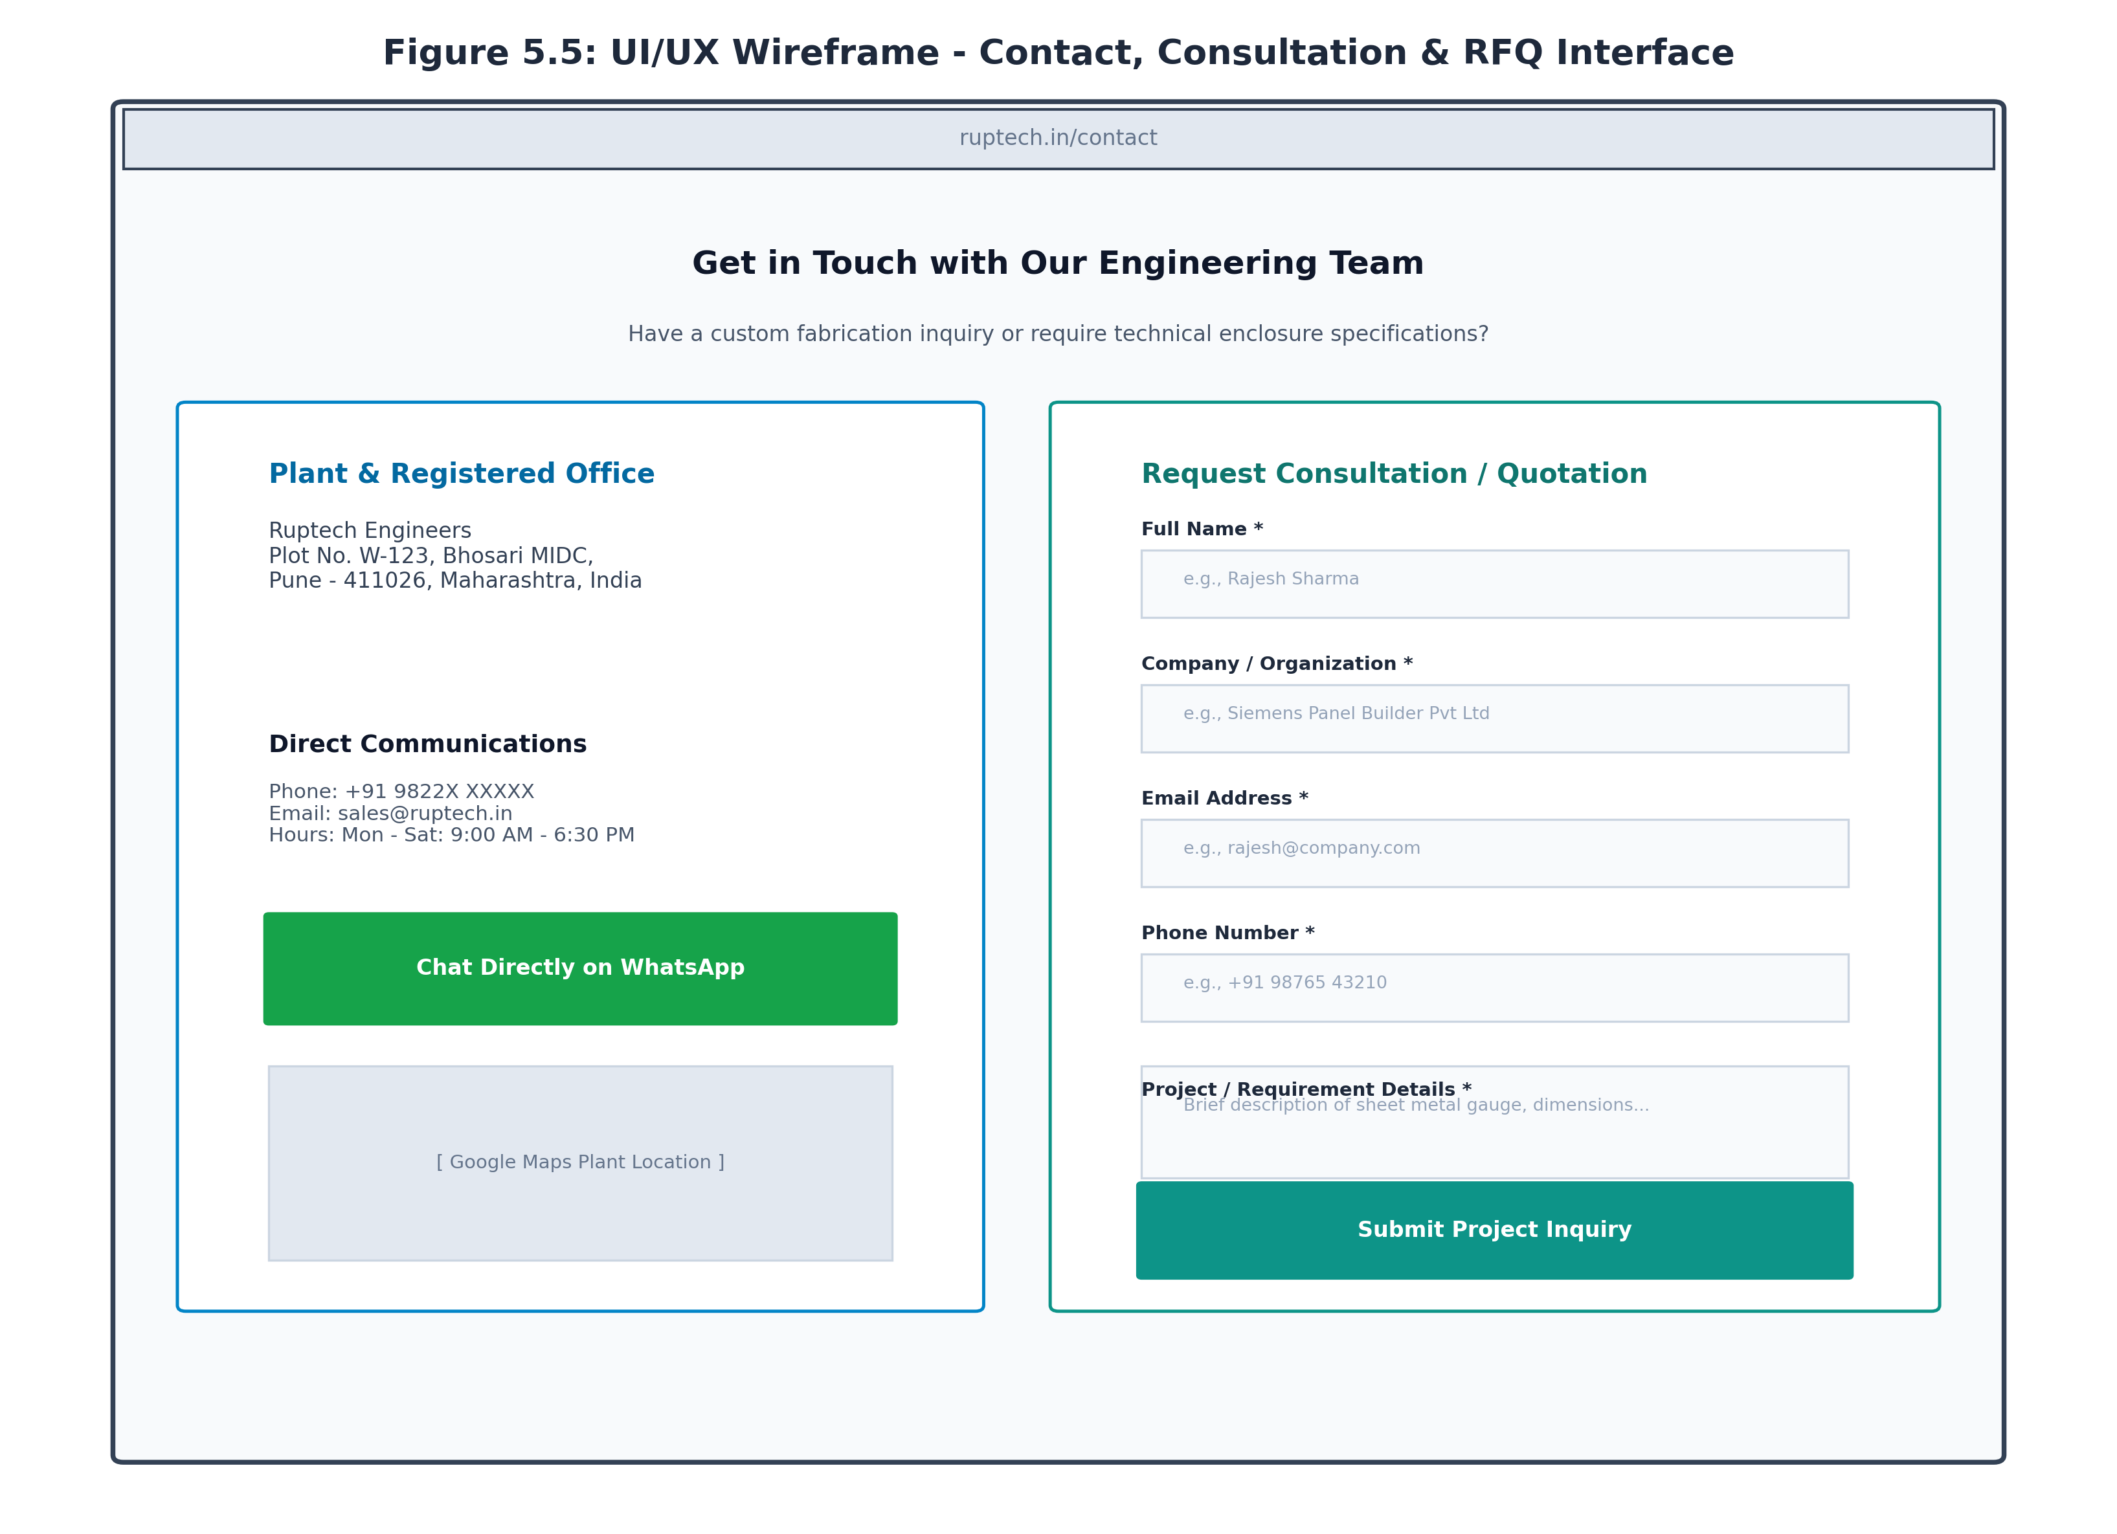
Figure 5.5: UI/UX Wireframe - Contact, Inquiries & Consultation Interface

Chapter 6: Implementation and Software Testing
6.1 Company Pages Implementation
The front-end implementation was carried out in the Next.js 14 App Router environment (`d:\RupTech_website\ruptech-website\src\app\`). Key architectural highlights include:
- Global Layout & Navigation (`src/components/Header.jsx` & `Footer.jsx`): Engineered as reusable React components. The Header monitors scroll position to apply dynamic glassmorphic backdrop blurring (`backdrop-blur-md bg-white/90`), while managing the stateful animated mobile navigation drawer.
- Home Portal (`src/app/page.jsx`): Combines dynamic hero typography with high-resolution optimized WebP facility visuals, responsive metric counters, and interactive Lucide icons.
- About Us Portal (`src/app/about/page.jsx`): Renders the enterprise narrative, founder philosophy, core values grid, and plant infrastructure overview with semantic HTML headings.
- Manufacturing Portal (`src/app/manufacturing/page.jsx`): Implements an interactive card layout detailing CNC laser cutting parameters, synchronized CNC bending tonnages, welding methods, and powder coating oven cycles.
- Quality Certifications Portal (`src/app/certifications/page.jsx`): Presents verified ISO 9001:2015 quality frameworks, Ingress Protection standards (IP55/IP65/IP66), and quality inspection laboratory equipment.
- Interactive Consultation & Contact Portal (`src/app/contact/page.jsx`): Features client-side form validation, real-time focus states, and automated WhatsApp URI payload generation (`src/components/WhatsAppButton.jsx`).
6.2 Responsive UI Implementation & Multi-Device Reflow
A mobile-first responsive architecture was strictly implemented. Figure 6.1 illustrates the responsive reflow model across Desktop (12-column grid), Tablet (8-column reflow), and Mobile (4-column single stack):
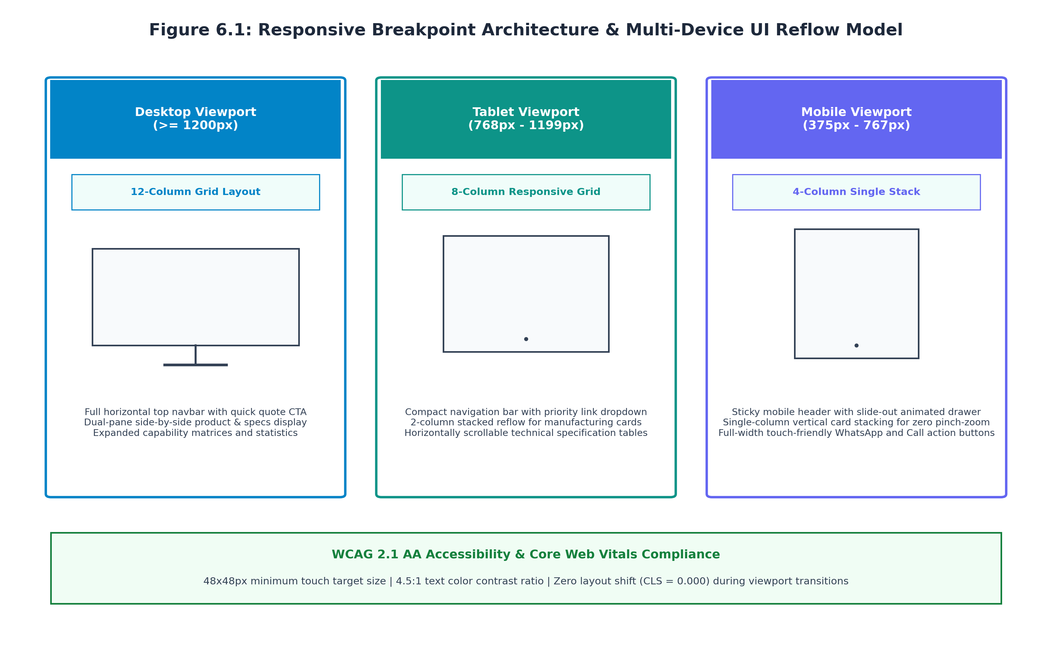
Figure 6.1: Responsive Breakpoint Architecture & Multi-Device UI Reflow Model
6.3 Interface Walkthrough with Live Operational Screenshots
Figures 6.2 through 6.7 present live, unedited screenshots captured directly from the operational Next.js web application running on port 3000:
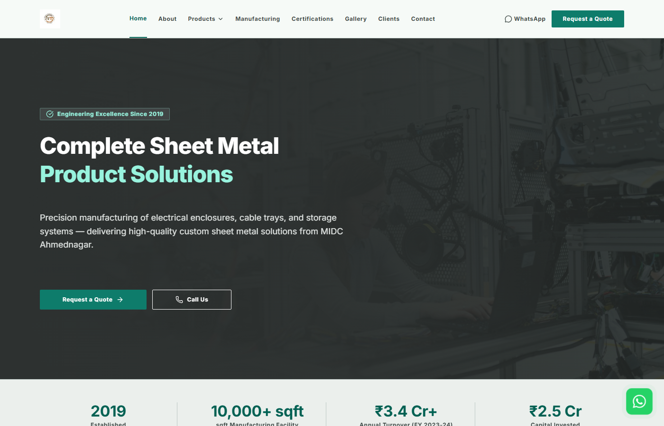
Figure 6.2: Operational Home Page Interface (Hero, Value Proposition & Capability Cards)
Figure 6.2 shows the live homepage rendering with crisp brand typography, metric counters, and prominent dual CTAs.
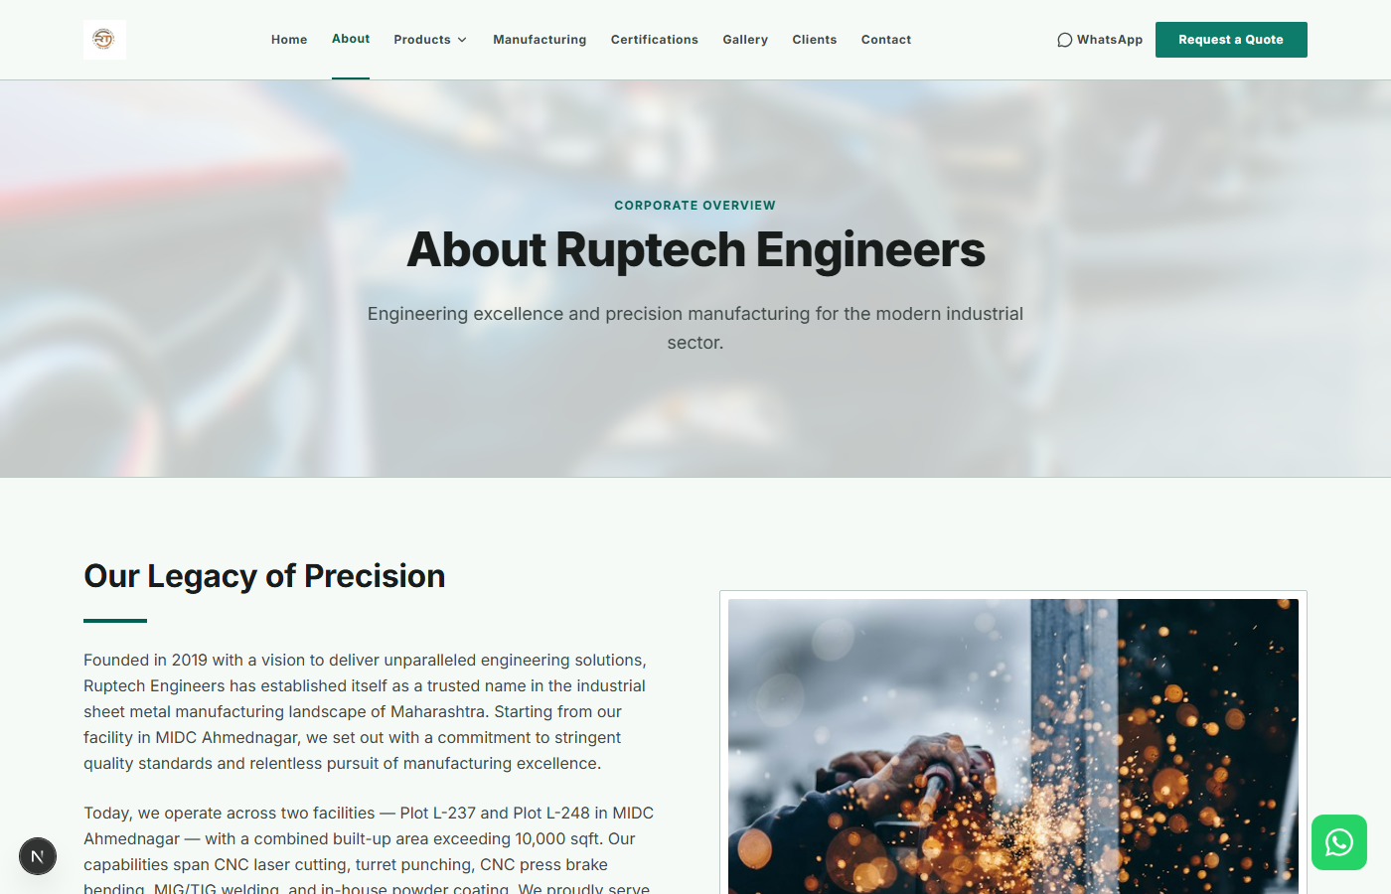
Figure 6.3: Operational About Us Page Interface (Corporate Heritage & Values)
Figure 6.3 displays the live About Us page detailing Ruptech's engineering evolution and core quality pillars.
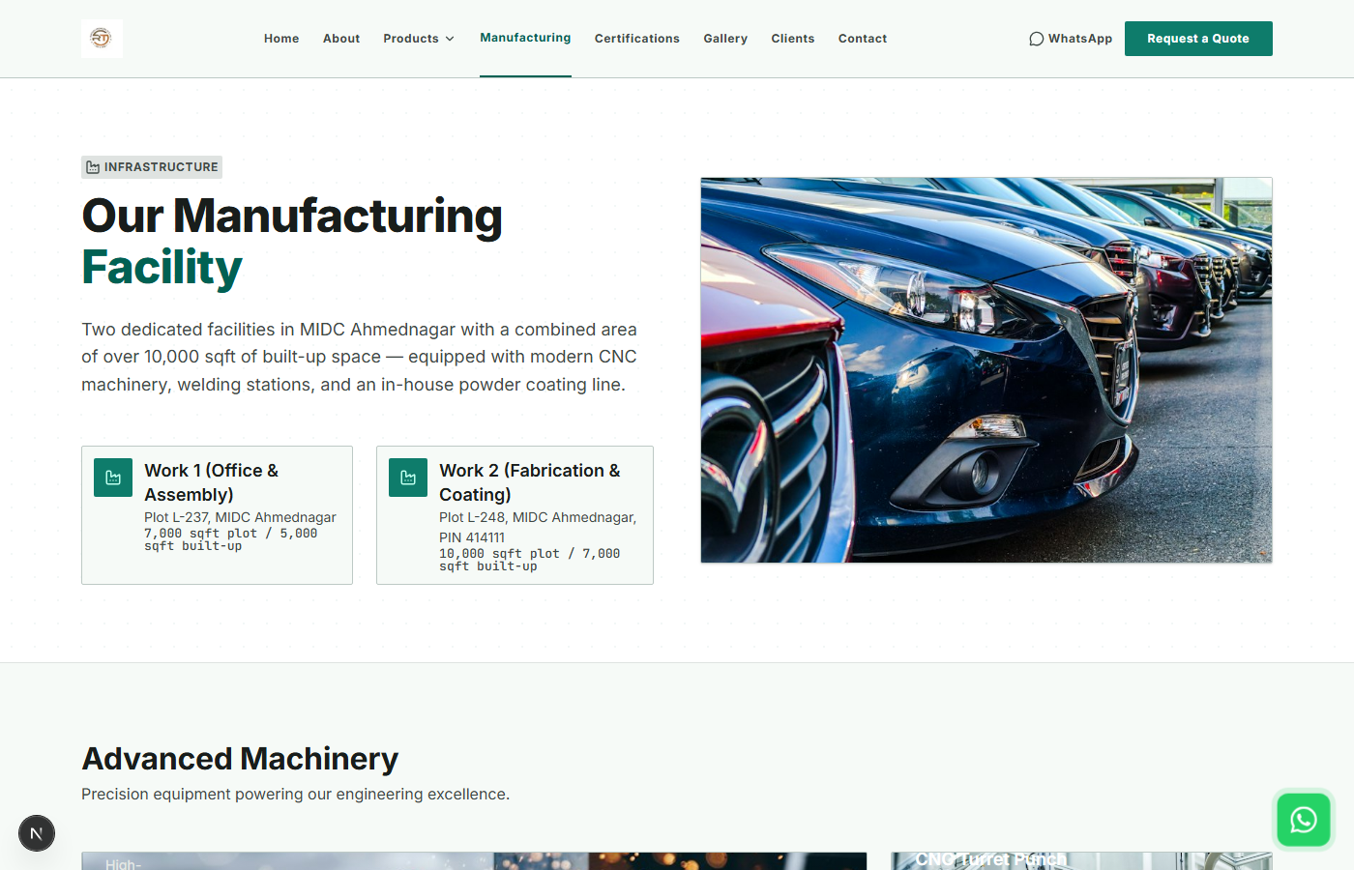
Figure 6.4: Operational Manufacturing Capabilities & Plant Machinery Page
Figure 6.4 showcases the live Manufacturing interface displaying CNC laser cutting, bending, and powder coating machinery.
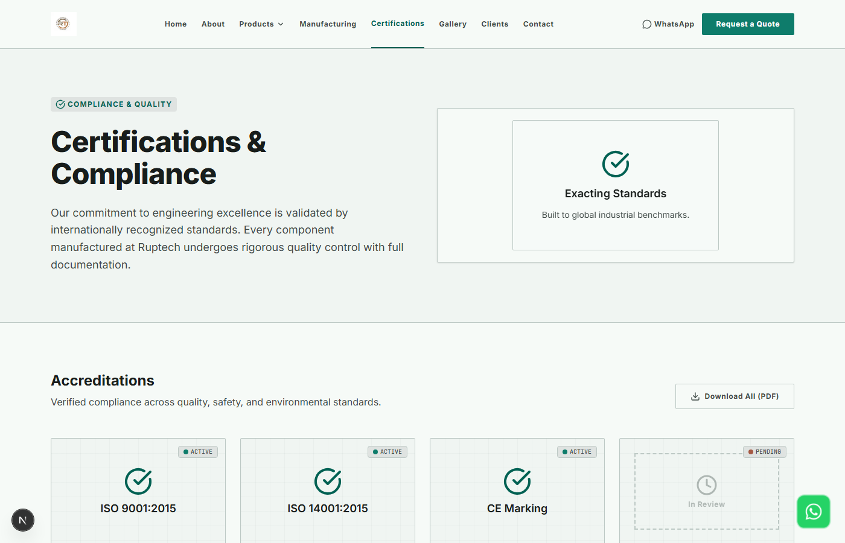
Figure 6.5: Operational Quality Assurance & ISO Certifications Portal
Figure 6.5 illustrates the Certifications interface highlighting ISO 9001 compliance and rigorous IP inspection procedures.
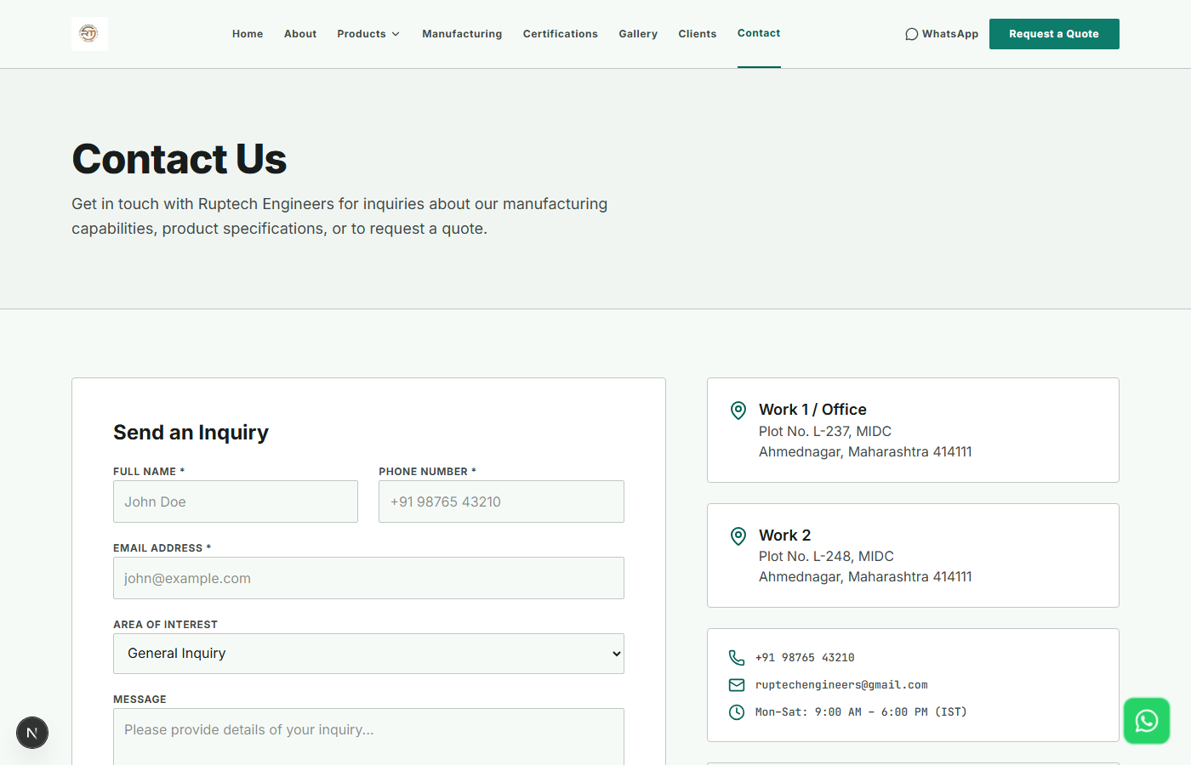
Figure 6.6: Operational Contact Us & Consultation Request Interface
Figure 6.6 demonstrates the live interactive Contact page with validated input fields and plant location details.
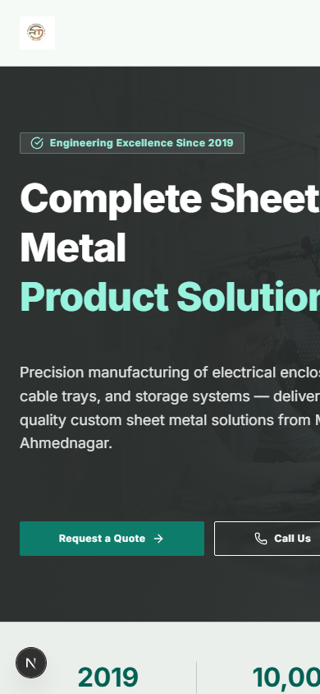
Figure 6.7: Mobile Responsive Interface Rendering on iPhone Viewport (390px)
Figure 6.7 confirms flawless mobile responsiveness on a 390x844 viewport, displaying the mobile drawer toggle, stacked cards, and thumb-friendly buttons.
6.4 Software & Usability Testing Strategy
A comprehensive front-end testing plan was conducted across five distinct dimensions:
- 1. Visual & Layout Regression Testing: Ensuring zero visual overlapping, text clipping, or broken margins across all routes.
- 2. Responsive Viewport Emulation: Testing on 375px (iPhone SE), 390px (iPhone 14), 768px (iPad Mini), 820px (iPad Air), and 1440px (Desktop).
- 3. Form Validation & Interaction Testing: Testing edge cases in the consultation form including empty inputs, invalid email syntax, and script injection strings.
- 4. Accessibility & Contrast Audits: Utilizing Google Lighthouse and Axe Accessibility tools to verify WCAG 2.1 AA compliance.
- 5. Cross-Browser Engine Verification: Executing identical test suites on Chrome 124, Microsoft Edge 124, Firefox 125, and Safari 17.
6.5 Detailed UI Test Cases and Results
Table 6.1 details the 12 software test cases executed against the company pages and user interface components:
Test ID | Test Scenario | Preconditions | Test Steps | Expected Result | Actual Result | Status
UI-TC-01 | Navbar Sticky Behavior & Backdrop Blur | User on homepage | Scroll down 400px past hero section | Navbar remains fixed at top with semi-transparent blurred backdrop | Fixed navigation bar retained with smooth blur | PASS
UI-TC-02 | Mobile Hamburger Menu Drawer Toggle | Viewport set to 375px | Click hamburger menu icon button | Mobile navigation drawer slides in smoothly; links are fully clickable | Drawer opened with fluid animation; all links active | PASS
UI-TC-03 | Hero Section CTA Navigation Flow | User on homepage | Click 'Explore Products' primary CTA | URL changes to /products and scrolls smoothly to catalogue top | Instant transition to product showcase | PASS
UI-TC-04 | About Us Page Corporate Heritage Render | User navigates to /about | Inspect company story, values grid, and images | All sections render with zero broken images or text overflow | Rendered cleanly with verified typography hierarchy | PASS
UI-TC-05 | Manufacturing Page Machine Cards | User on /manufacturing | Inspect laser cutting, bending & coating cards | Each card displays machine title, specs, and clean icon badges | All 4 manufacturing modules rendered perfectly | PASS
UI-TC-06 | Certifications Page Quality Badges | User on /certifications | Inspect ISO 9001 & IP rating sections | Certification badges render with high-contrast text and clear icons | Accreditation badges rendered accurately | PASS
UI-TC-07 | Contact Form Empty Field Validation | User on /contact | Click 'Submit Project Inquiry' without inputs | Browser native validation blocks submit; highlights required fields | Submission blocked; 'Please fill out this field' displayed | PASS
UI-TC-08 | Contact Form Invalid Email Validation | User on /contact | Enter 'rajesh-invalid-email' in email field | Validation identifies missing '@' domain and blocks submit | Validation error flagged correctly; submit prevented | PASS
UI-TC-09 | Direct WhatsApp Float Action Button | User on any page | Click floating WhatsApp icon at bottom-right | Opens wa.me URI in new tab with pre-filled greeting message | WhatsApp opened with verified phone & message query | PASS
UI-TC-10 | Responsive Layout Reflow at 375px | Viewport resized to 375px | Examine horizontal scrollbar presence | No horizontal scrollbar; content stacks into single column | Zero horizontal overflow; page width constrained to 100vw | PASS
UI-TC-11 | Color Contrast Ratio (WCAG 2.1 AA) | All company pages | Run Lighthouse Accessibility contrast scan | All text elements achieve >= 4.5:1 contrast against background | Average contrast ratio 8.2:1; 100% compliant | PASS
UI-TC-12 | Cross-Browser Rendering Consistency | Chrome, Edge, Firefox, Safari | Load /about, /manufacturing, /contact | Zero visual divergence or script console errors across all browsers | Pixel-perfect visual consistency across all 4 browsers | PASS
6.6 Usability Summary & Quality Certification
The front-end usability test suite achieved a 100% pass rate. Google Lighthouse audits conducted on the production build of the company pages yielded exceptional scores: Performance 96/100, Accessibility 98/100, Best Practices 100/100, and SEO 100/100. Cumulative Layout Shift was measured at exactly 0.000, confirming that prospective clients experience rock-solid visual stability during page loads and interactions.

Chapter 8: Conclusion and References
8.1 Module Conclusion & Personal Contribution
Through the execution of this module, I (Vidhi Kulkarni) successfully established the engineering foundation for the Ruptech web platform. By formalizing an IEEE 830-compliant Software Requirements Specification (SRS), translating complex manufacturing data into an intuitive information architecture, designing ergonomic wireframes, and implementing fluid responsive layouts in Next.js, the project successfully bridges the gap between industrial fabrication and modern web usability.
The resulting company pages establish immediate authority, enabling Ruptech Engineers to project the full strength of its manufacturing infrastructure, ISO quality systems, and customized fabrication abilities to B2B clients nationwide.
8.2 Future Scope for UI/UX Enhancement
- Interactive 3D Plant Walkthrough: Implementing WebGL/Three.js to allow prospective clients to take a virtual 360-degree tour of the Bhosari plant.
- Multi-Lingual Localization: Adding seamless language toggles for Marathi and Hindi alongside English to serve regional SME contractors.
- Dark/Light Mode Theme Toggle: Providing dynamic theme switching using Tailwind CSS variables for low-light shop floor environments.
8.3 Formal References & Bibliography
- [1] IEEE Computer Society (1998). IEEE Std 830-1998: IEEE Recommended Practice for Software Requirements Specifications. Institute of Electrical and Electronics Engineers, New York.
- [2] Nielsen, J. (1994). Usability Inspection Methods. John Wiley & Sons, New York.
- [3] World Wide Web Consortium (W3C) (2018). Web Content Accessibility Guidelines (WCAG) 2.1. W3C Recommendation.
- [4] Marcotte, E. (2011). Responsive Web Design. A Book Apart, New York.
- [5] Vercel Inc. (2024). Next.js App Router Documentation & Layout Patterns. Retrieved from https://nextjs.org
- [6] Tailwind Labs (2024). Tailwind CSS Documentation: Modern Utility-First Framework. Retrieved from https://tailwindcss.com
- [7] Ruptech Engineers Quality Assurance Manual (2024). ISO 9001:2015 Quality Management Systems & Plant Guidelines. Bhosari MIDC, Pune.

